Nom : Archimède[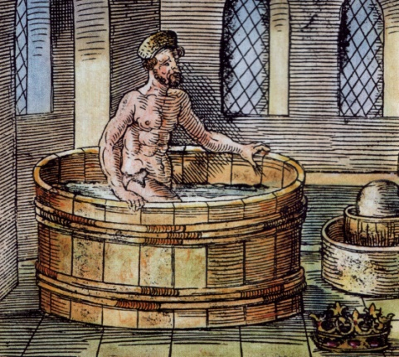](https://www.google.ca/url?sa=i&rct=j&q=&esrc=s&source=images&cd=&cad=rja&uact=8&ved=0CAcQjRxqFQoTCOOVorGswsgCFcxbPgodOsQPXw&url=https://en.wikipedia.org/wiki/Eureka_(word)&bvm=bv.104819420,d.cWw&psig=AFQjCNGOk5deaiq3K3PctEGb0Vm4ttDh2Q&ust=1444925308916373)

Nationalité :grec

Période 3eme sciécle avant J-C

Carte[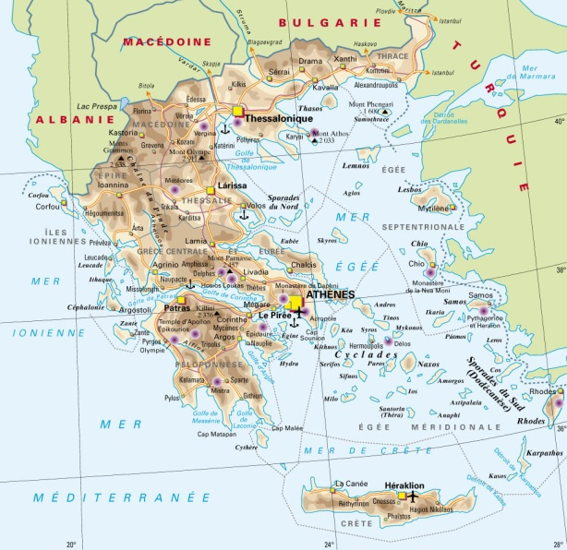](http://www.google.ca/url?sa=i&rct=j&q=&esrc=s&source=images&cd=&cad=rja&uact=8&ved=0CAcQjRxqFQoTCLeu2emrwsgCFcs_Pgodr44HCw&url=http://cd16cyclisme.com/tag-carte-Gr%C3%A8ce.html&bvm=bv.104819420,d.cWw&psig=AFQjCNFlUsrAI82fblKCgs4sJ8az9xFw5A&ust=1444925131563286)

Drapeau[](https://www.google.ca/url?sa=i&rct=j&q=&esrc=s&source=images&cd=&cad=rja&uact=8&ved=0CAcQjRxqFQoTCNWqxrarwsgCFUSPPgodx-QJow&url=https://fr.wikipedia.org/wiki/Drapeau_de_la_Gr%C3%A8ce&psig=AFQjCNFqAYBZn4v-jVEeJSSmEPVk_ggrRw&ust=1444924983616337)