[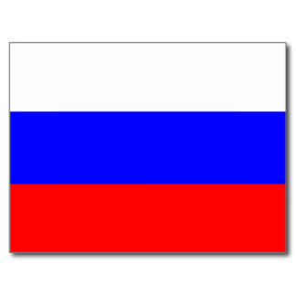](http://www.google.ca/url?sa=i&rct=j&q=&esrc=s&source=images&cd=&cad=rja&uact=8&ved=0CAcQjRxqFQoTCNaev5rH5cgCFYEaPgodO5kA3Q&url=http%3A%2F%2Fwww.zazzle.fr%2Fdrapeau%2Bde%2Bla%2Brussie%2Bcartes%2Bpostales&bvm=bv.106130839,d.dmo&psig=AFQjCNH0V13gKoQAc9OIgwin1f3TZRRmnQ&ust=1446135099399353)Mendeleïev

[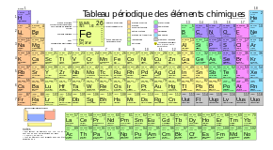](https://www.google.ca/url?sa=i&rct=j&q=&esrc=s&source=images&cd=&cad=rja&uact=8&ved=0CAcQjRxqFQoTCNPh1ZDH5cgCFQZ7PgodXdcLag&url=https%3A%2F%2Ffr.wikipedia.org%2Fwiki%2FTableau_p%25C3%25A9riodique_des_%25C3%25A9l%25C3%25A9ments&bvm=bv.106130839,d.dmo&psig=AFQjCNEtTl9OFEO1eNrGvAhJ7uMGGPnJvw&ust=1446135061328194)Nom complet : Dimitri Ivanovitch Mendeleïev

Nationalité : Russe(Russie)

Période de temps : 1834-1907

Livre : tableau périodique

**[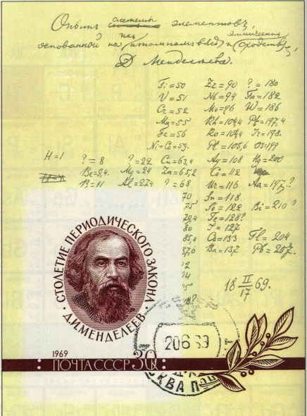](http://www.google.ca/url?sa=i&rct=j&q=&esrc=s&source=images&cd=&cad=rja&uact=8&ved=0CAcQjRxqFQoTCPSo-93H5cgCFUl2PgodpHYCvw&url=http%3A%2F%2Fcraq-astro.ca%2Fphy1971%2Fchap4%2Findex4.html&bvm=bv.106130839,d.dmo&psig=AFQjCNHAnJA8fSQLsShihthCA2Qqew0rUw&ust=1446135236305186)**

[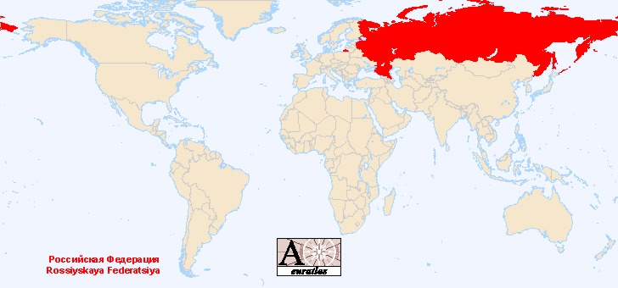](http://www.google.ca/url?sa=i&rct=j&q=&esrc=s&source=images&cd=&cad=rja&uact=8&ved=0CAcQjRxqFQoTCPvGka_H5cgCFYY3Pgodbn4CnA&url=http%3A%2F%2Fwww.euratlas.net%2Fgeography%2Fworld%2Fcountries%2Ffr_russia.html&bvm=bv.106130839,d.dmo&psig=AFQjCNEEvRgFQ_anrtNIndBLlU7uPyDBDQ&ust=1446135144439905)

[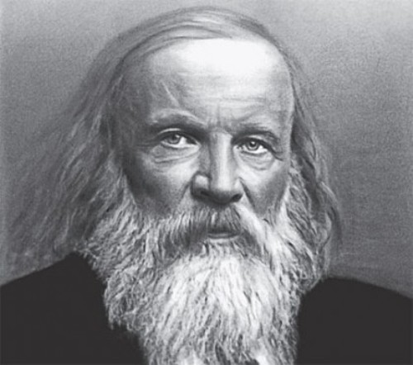](http://www.google.ca/url?sa=i&rct=j&q=&esrc=s&source=images&cd=&cad=rja&uact=8&ved=0CAcQjRxqFQoTCKb6jLj86sgCFYwaPgodqsENdA&url=http%3A%2F%2Fwww.myinterestingfacts.com%2Fdmitri-mendeleev-facts%2F&psig=AFQjCNFkjXTGi7uKhWaDez5iYgBwlTv4vg&ust=1446321188839999)

[](http://www.google.ca/url?sa=i&rct=j&q=&esrc=s&source=images&cd=&cad=rja&uact=8&ved=0CAcQjRxqFQoTCKb6jLj86sgCFYwaPgodqsENdA&url=http%3A%2F%2Fwww.myinterestingfacts.com%2Fdmitri-mendeleev-facts%2F&psig=AFQjCNFkjXTGi7uKhWaDez5iYgBwlTv4vg&ust=1446321188839999)