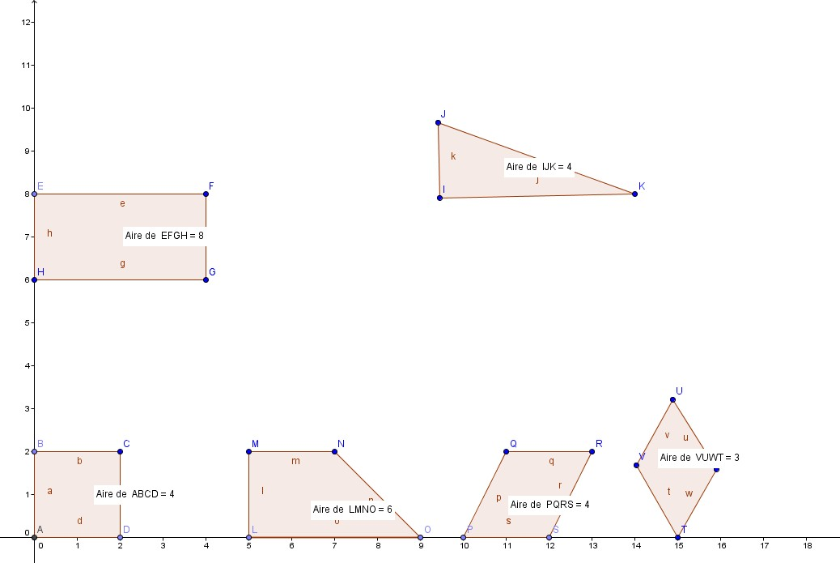

#triangle A=bxh/2 = 2x4 / 2 =4
Carré :a=CxC= 2 x2 =4cm
Trapeze rectengleA=(B=b)xh32=4+2x2/2=6
rectengleA+bxh = 2x 4 =8
ParalélogrameA=bxh=2X2=4

Losange :A=Dxd /2=2x3/2=3

