Mendeleïev

[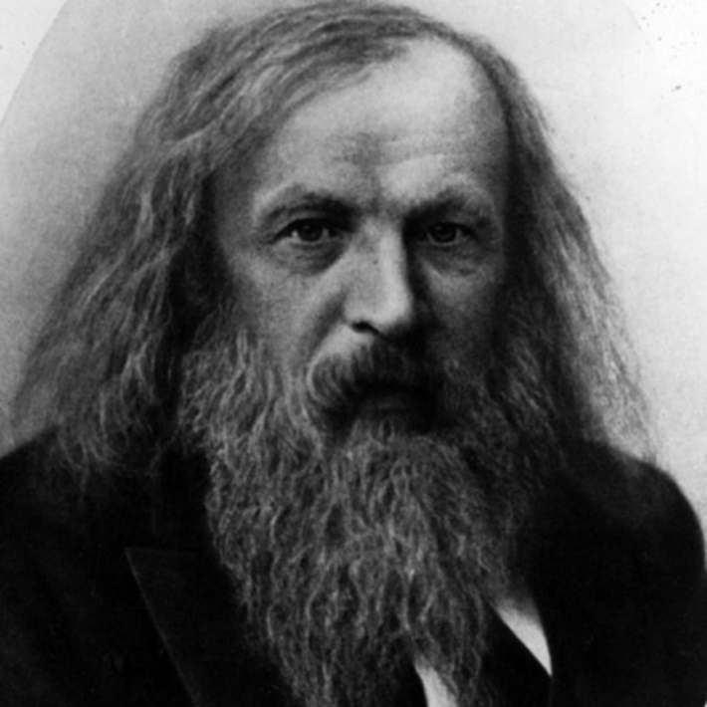](http://www.google.ca/url?sa=i&rct=j&q=&esrc=s&source=images&cd=&cad=rja&uact=8&ved=&url=http://www.biography.com/people/dmitri-mendeleyev-9405465&psig=AFQjCNFj0KP9Z19hg-8QiTMgzH3tV64srw&ust=1445641314676843)

Nom au complet : Dimitri Mendeleïev

Localité : Russe

Pays : Russie

Période de temps : 1834-1907

[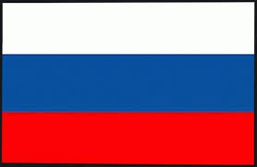](http://www.google.ca/imgres?imgurl=http://s4.e-monsite.com/2011/05/22/12/resize_550_550//le-drapeau-de-la-russie-2699085rwonj1.jpg&imgrefurl=http://pingours-russie.e-monsite.com/pages/introduction.html&h=359&w=550&tbnid=GGxB8yMCHNBnTM:&docid=oiOFwDWcUglBdM&ei=gWwpVqbsF4Ln-wHduI3ICA&tbm=isch&ved=0CD8QMygOMA5qFQoTCOawpZ-Z18gCFYLzPgodXVwDiQ)Œuvre : tableau périodique des éléments

[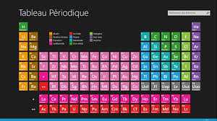](http://www.google.ca/imgres?imgurl=https://store-images.microsoft.com/image/apps.1588.9007199266252004.e78ececc-f07c-4ada-9e1e-295b0b68cd25.315e23ba-a2c5-4552-8ac0-c50219d48fef?w=712&h=400&mode=letterbox&background=black&imgrefurl=https://www.microsoft.com/fr-ca/store/apps/tableau-periodique-des-elements/9wzdncrfjb1f&h=400&w=712&tbnid=xyc5dBPxbOKAQM:&docid=wq0GCZEiwM2USM&ei=tGspVs2ZKMbS-QHylb-QDg&tbm=isch&ved=0CFEQMygWMBZqFQoTCM3D1b2Y18gCFUZpPgod8soP4g)[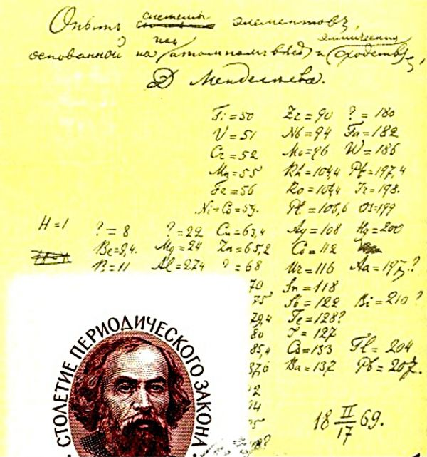](http://www.google.ca/url?sa=i&rct=j&q=&esrc=s&source=images&cd=&cad=rja&uact=8&ved=0CAcQjRxqFQoTCKqB68TB5cgCFUE5PgodJaoPXw&url=http%3A%2F%2Fwww.ilephysique.net%2Fsujet-la-classification-periodique-des-elements-261804.html&bvm=bv.106130839,d.dmo&psig=AFQjCNGKdUZMBHAEWQddJy2Nv9G0rnAt_g&ust=1446133558285820)[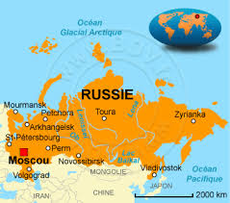](http://www.google.ca/imgres?imgurl=http://www.bourse-des-voyages.com/commun//images/cartes/carte-russie.gif&imgrefurl=http://www.bourse-des-voyages.com/guide-voyage/vacances/pays-russie-4.html&h=300&w=340&tbnid=G8SaiNWv_rarVM:&docid=VJhgvSHRVg9C-M&ei=8WwpVqTKK8vh-QHc0IeYAg&tbm=isch&ved=0CFkQMygeMB5qFQoTCOSG7dSZ18gCFctwPgodXOgBIw)