Israël

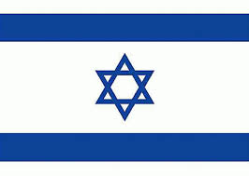Drapeaux :

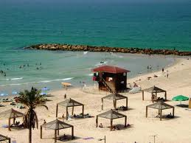D’autres images :

|  |  |  |  |  |  |  |  |  |  |  |  |  |  |  |  |  |  |  |  |  |  |  |  |  |  |  |  |  |  |  |
| --- | --- | --- | --- | --- | --- | --- | --- | --- | --- | --- | --- | --- | --- | --- | --- | --- | --- | --- | --- | --- | --- | --- | --- | --- | --- | --- | --- | --- | --- | --- |
| |  |  | | --- | --- | | enfant non scolarisé en Israël en âge pour l'école primaires deux sexes(nombre) | | | Années | Nombres d'élèves | | 1999 | 15 193 | | 2000 | 13752 | | 2001 | 10916 | | 2002 | 13169 | | 2003 | 12786 | | 2004 | 15883 | | 2005 | 17158 | | 2006 | 21072 | | 2007 | 19897 | | 2008 | 20518 | | 2009 | 23156 | | 2010 | 20236 | | 2011 | 23296 | |
|  |