PAYS

BELIZE

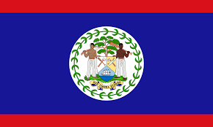

|  |  |
| --- | --- |
| eleve n`ayant pas acces a l`ecole (belize) |  |
| annee | nombre |
| 2010 |  |
| 2011 |  |
| 2012 |  |
| 2013 |  |
| 2013 |  |
| 2014 |  |
| 2015 |  |
| 2016 |  |
| 2017 |  |
| 2018 |  |