Little fighter
#1 AND YOU WERE ALWAYS ALONE OUT ON THE SEA

#2 WITHOUT A WEAPON IN YOUR HAND / YOU WERE A FIGHTER FOR PEACE
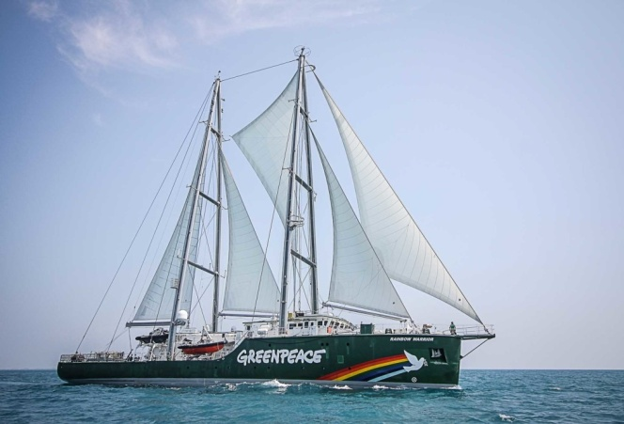
#3 white lion

#4 Rainbow warrior

#5 Green peace

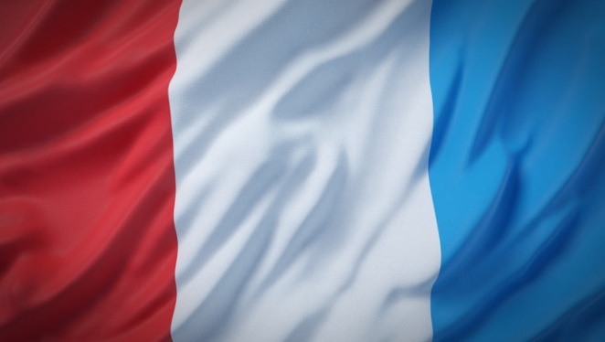
#6 le bateau a coulé

#7 service secret

#8 France

#9 mort d’un photographe

#10 Nouvelle-Zélande

#11 Francois Mitterand

