Phénomène visible la nuit

Fait par Tony

[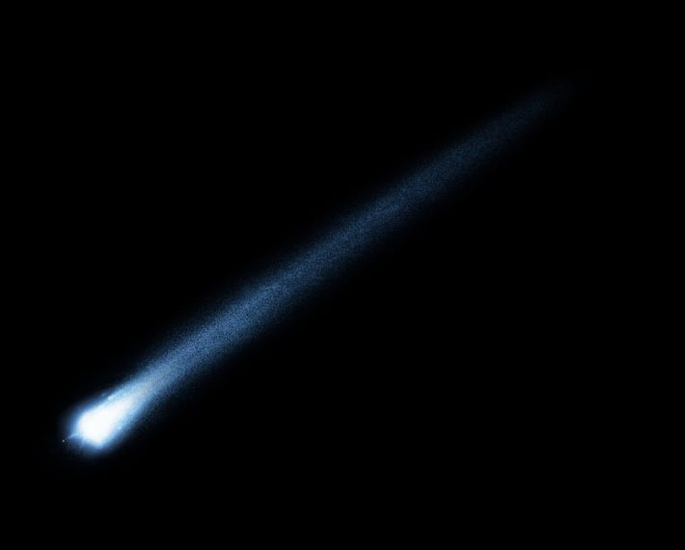](https://www.google.ca/url?sa=i&rct=j&q=&esrc=s&source=images&cd=&cad=rja&uact=8&ved=0ahUKEwjfmZ_SgNXWAhXs1IMKHRU0Bi4QjRwIBw&url=https%3A%2F%2Fwww.simplyscience.ch%2Farchives-enfants%2Farticles%2Fqu-est-ce-qu-une-etoile-filante.html&psig=AOvVaw2lkUkCLCWzOeJq_oLHD1j4&ust=1507139041057989)#1 Étoile filante

[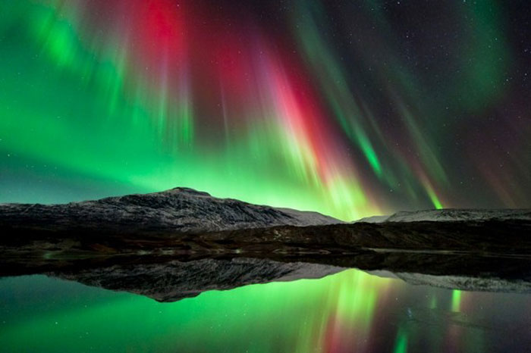](http://www.google.ca/url?sa=i&rct=j&q=&esrc=s&source=images&cd=&cad=rja&uact=8&ved=0ahUKEwjT3Ir3gNXWAhUq5oMKHVMXD6kQjRwIBw&url=http%3A%2F%2Fwww.startin-sport.com%2Fles-15-plus-belles-photos-aurores-boreales.htm&psig=AOvVaw1xM-uJfT328YRvgEQ_tga5&ust=1507139132089812)#2 aurores boréales

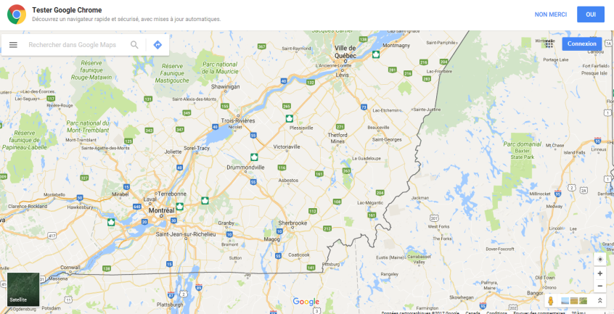#3

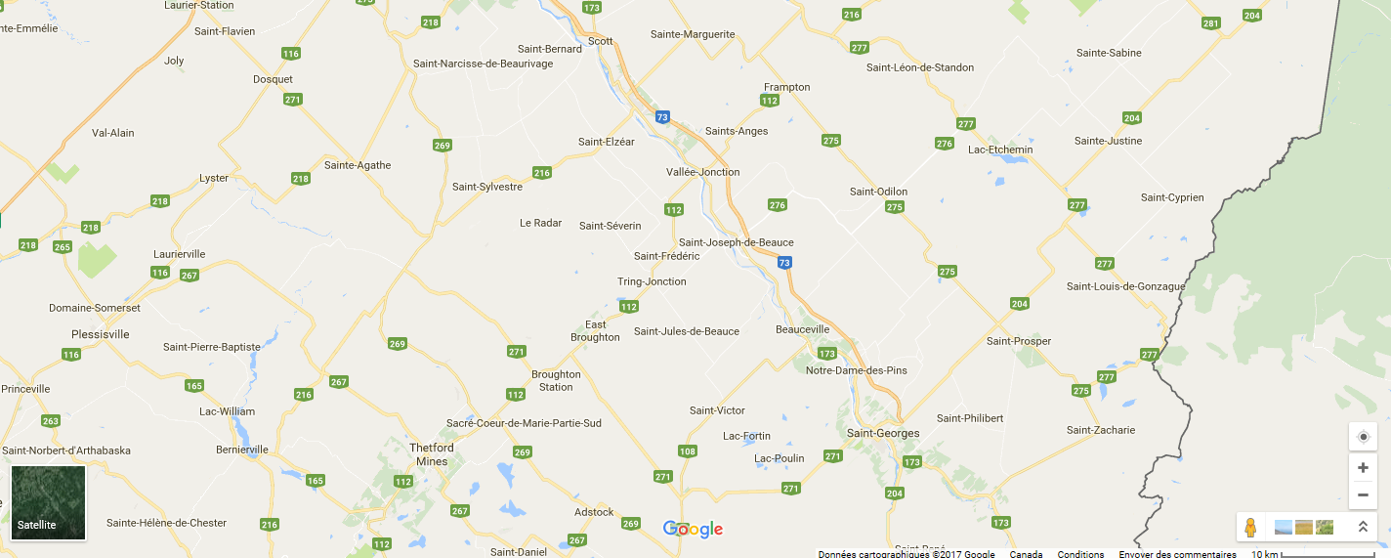#4

#5

