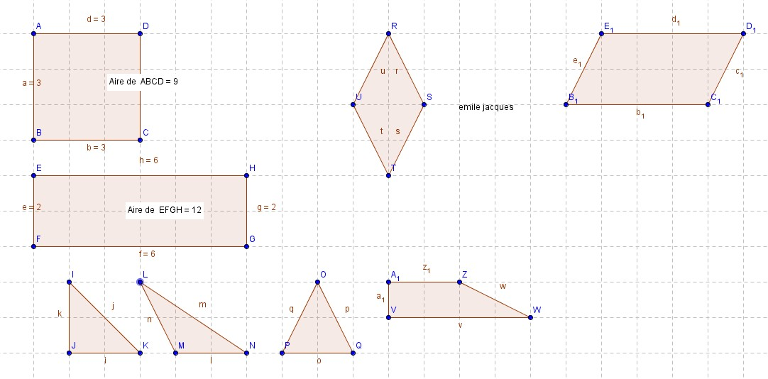

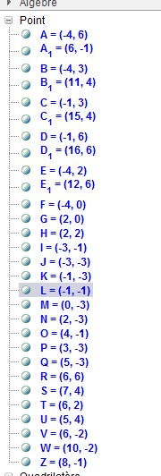
Aire du triangle =b x h / 2
= 2 x 2/2
= 2 cm²
Aire du carré =c x c
=3 x 3
=9cm²
Aire du rectangle =b x h
=6 x 2
= 12cm²
Aire du losange=D x d /2
=4 x 2 / 2 =4 cm ²
Parallélogramme= b x h / 2
=4 x 2 =8 cm²
Trapèze= (B x b) x h /2
= (4+2) x 1 /2 =3cm²

